Computer-Vision---Project-1-Double-Double-Dominoes-score-calculator

Ariton Cosmin

# Regular tasks

The summary of the main idea behind solving this tasks is using a perspective transform to align the images to a template. Extract features from the template and later use them on the aligned images for creating masks of interest (patches). Subtract the background from the images and apply a threshold so that a heat map of the elements of interest is formed. Then take advantage of the disc shaped dots on the dominos and use a Hough transformation to identify the number of circles present on the domino piece. Knowing the layout of the board, the rules apriori and now the location and the type of the newly placed domino, we can very easily compute a the score of a player, which is the task at hand.

## Perspective transform

In the pursuit of solving the task at hand, I decided that the best approach would be to aim to solve the most difficult problem first with a robust solution, such that the rest would be automatically covered by this implementation.

Although a way easier implementation for the first two games exists, by using an image alignment similar to the one presented in the first Laboratory class, and by extension for the third game, by adding small increments of rotation and scale, one of the most robust implementations with regard of bringing an image aligned with a template should be an image stitching performed with SIFT features. The algorithm is similar to the one presented at the Laboratory class, the main key difference being that the hyper parameters were very carefully chosen. Speed was sacrificed for accuracy, giving RANSAC way more opportunities to find a good match. Also the ratio of nearest to $2^{nd}$ nearest descriptor was chosen smaller than the recommended 0.7, 0.75 due to poor matching resulting in perspective transformations that were suffering heavy translation with respect to the used template. The final results are impressive, images from game 4 and 5 being almost well aligned with the template used and images from the first three games being almost perfectly aligned.

### The following figure illustrates the images before alignment from the forth game

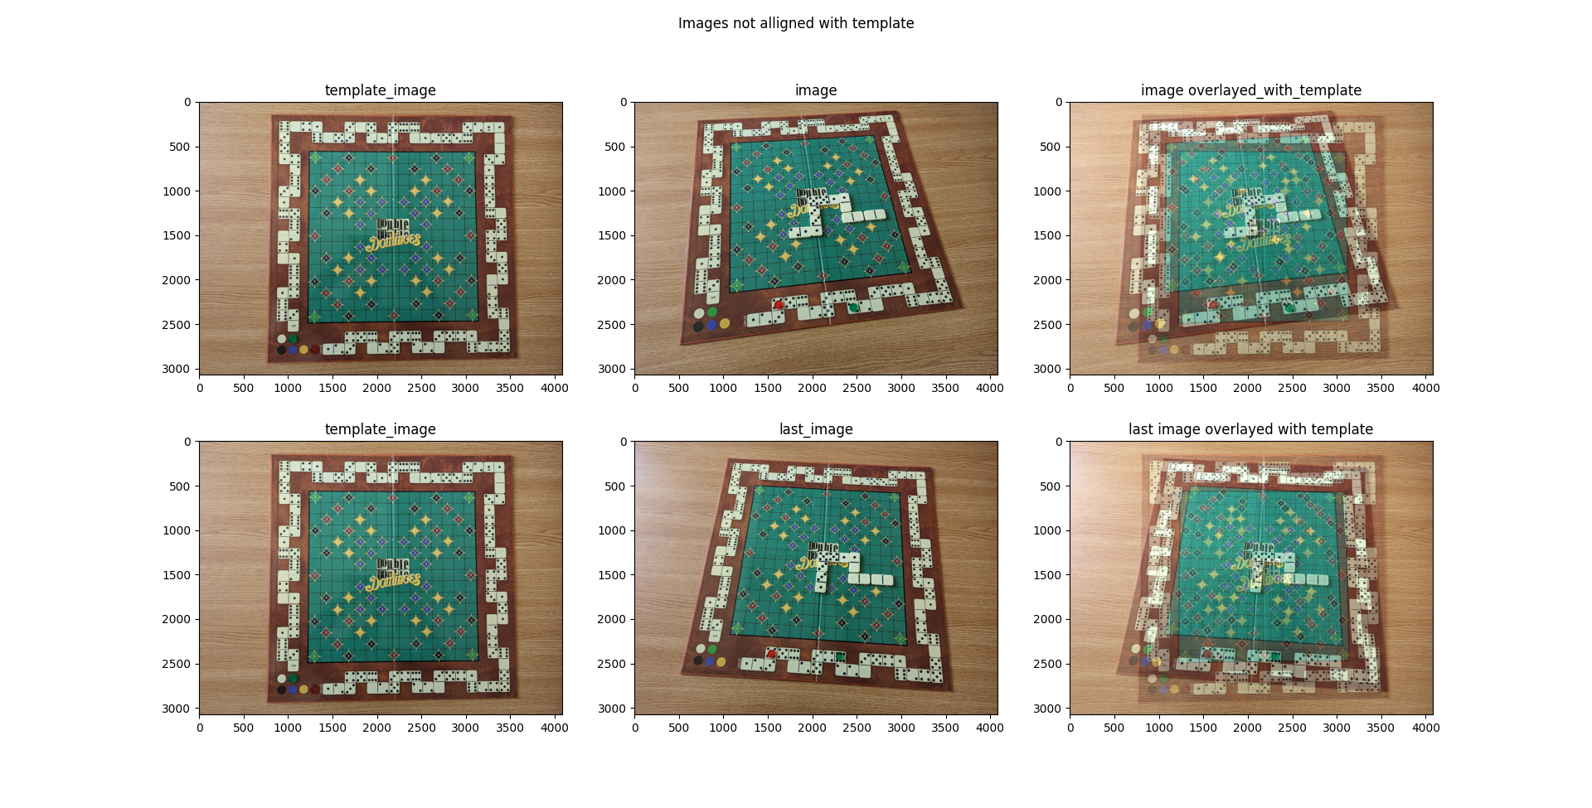

### The following figure illustrates the same images after alignment

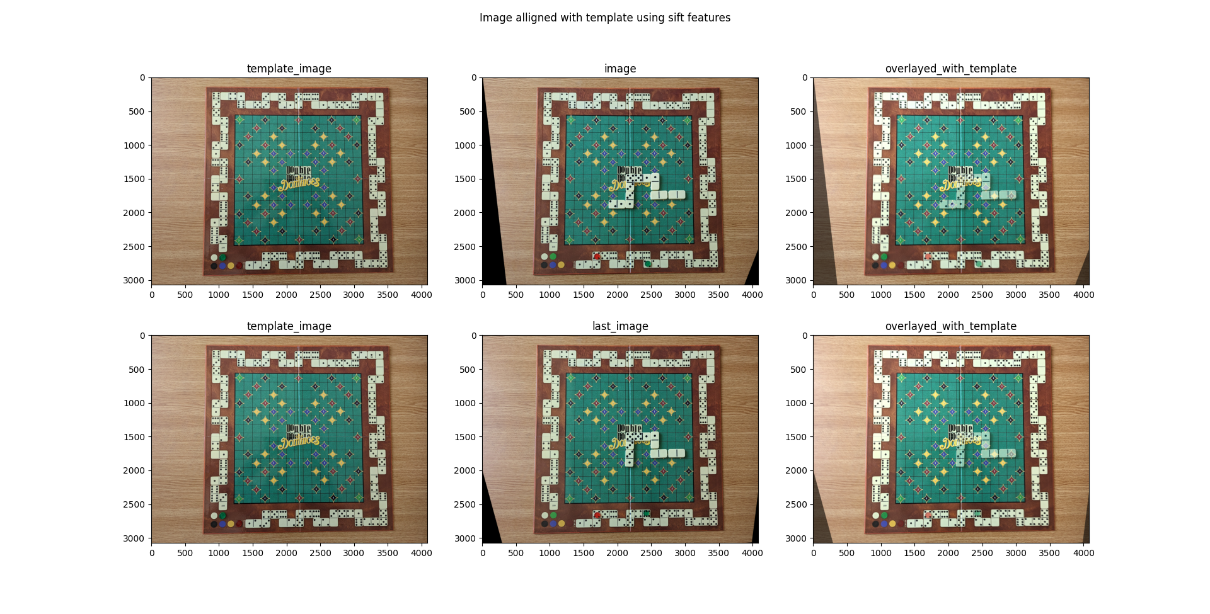

## Noise reduction

The usage of the median blur with a kernel size of 7 on the template image proved to be a very powerful tool by removing the unwanted noise without endangering the edges. The noise reduction led to less false positives when applying feature extraction methods.

## Feature extraction methods

### Canny edge detector

Canny edge detector proved to be essential in extracting edges from the template so that Hough Transform could work effectively for detecting lines. The most important aspect of it is the reduction of an edge width down to a single pixel. It also proves quite useful in eliminating unwanted noise in the image.

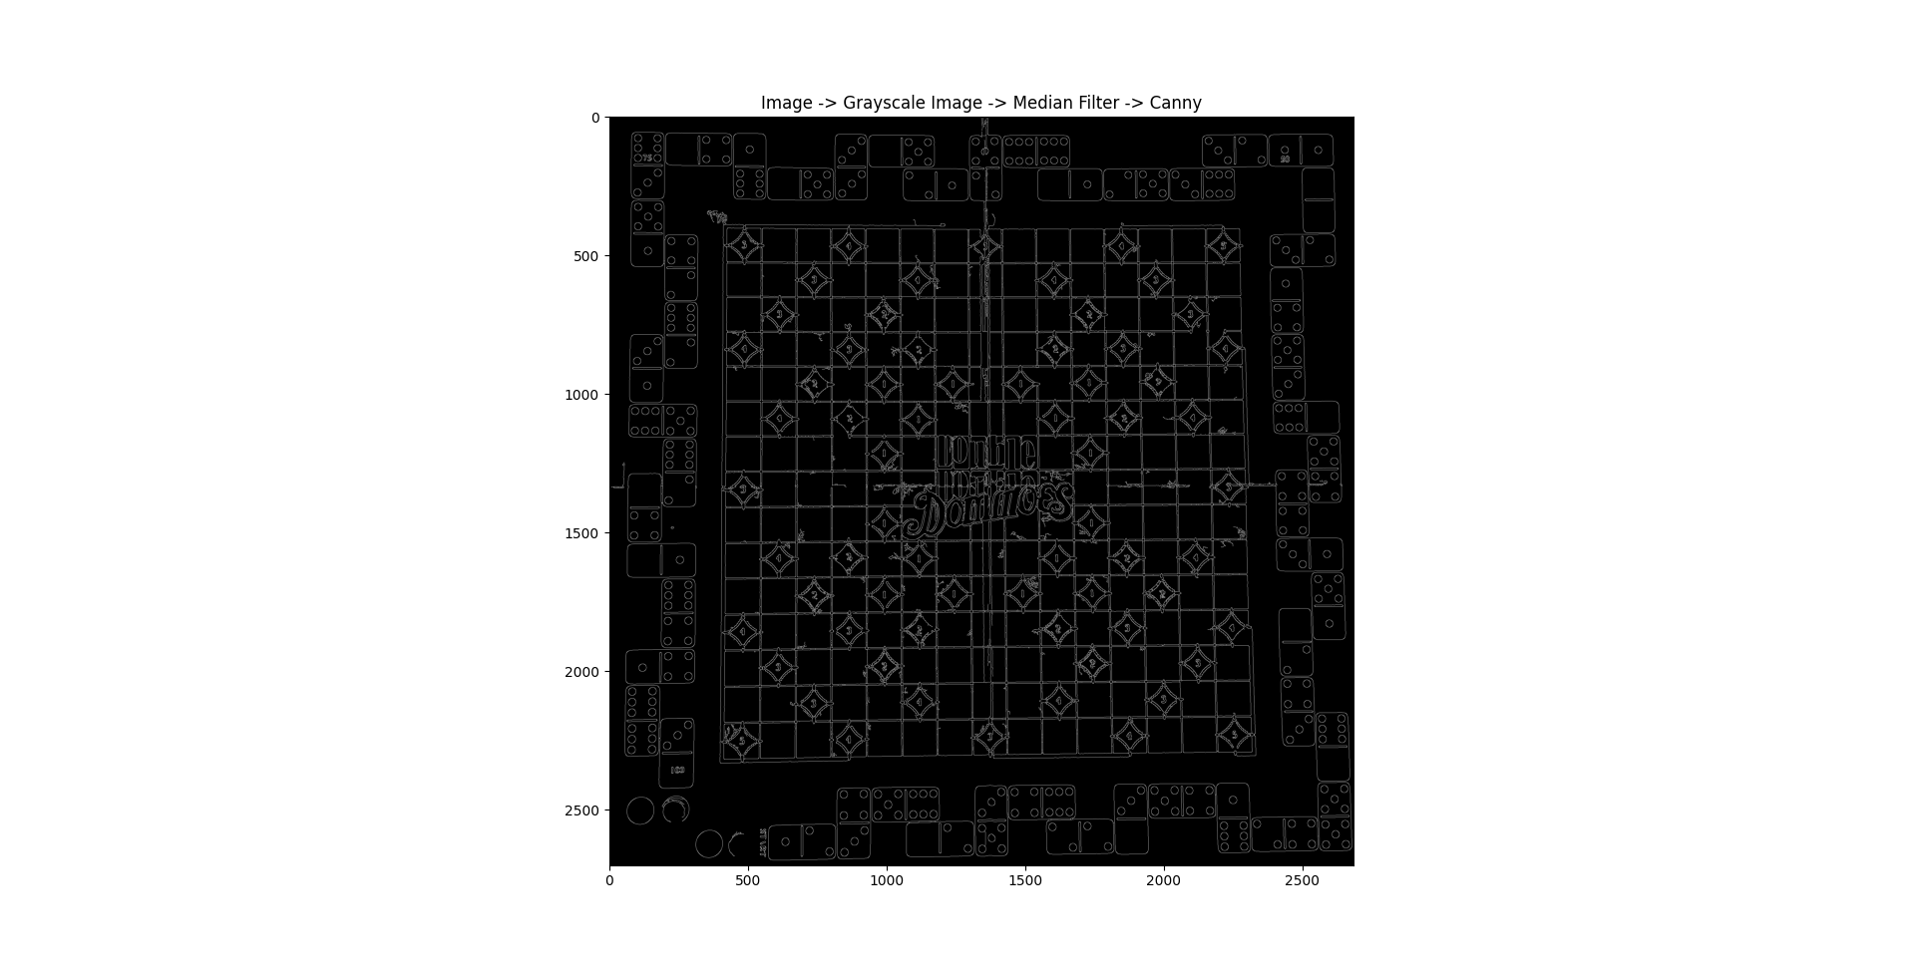

### Hough Transform

Hough transform proved very useful in finding the horizontal and vertical lines of the template image representing the grid on which the game is played. Some overlapping lines had to be removed for a comprehensive result. Using some simple math, the intersections of the lines were computed which represent the corners of the rectangles determining the grid.

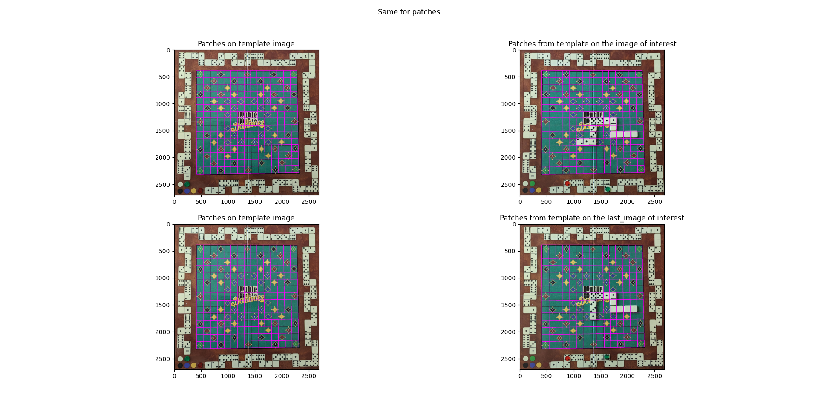

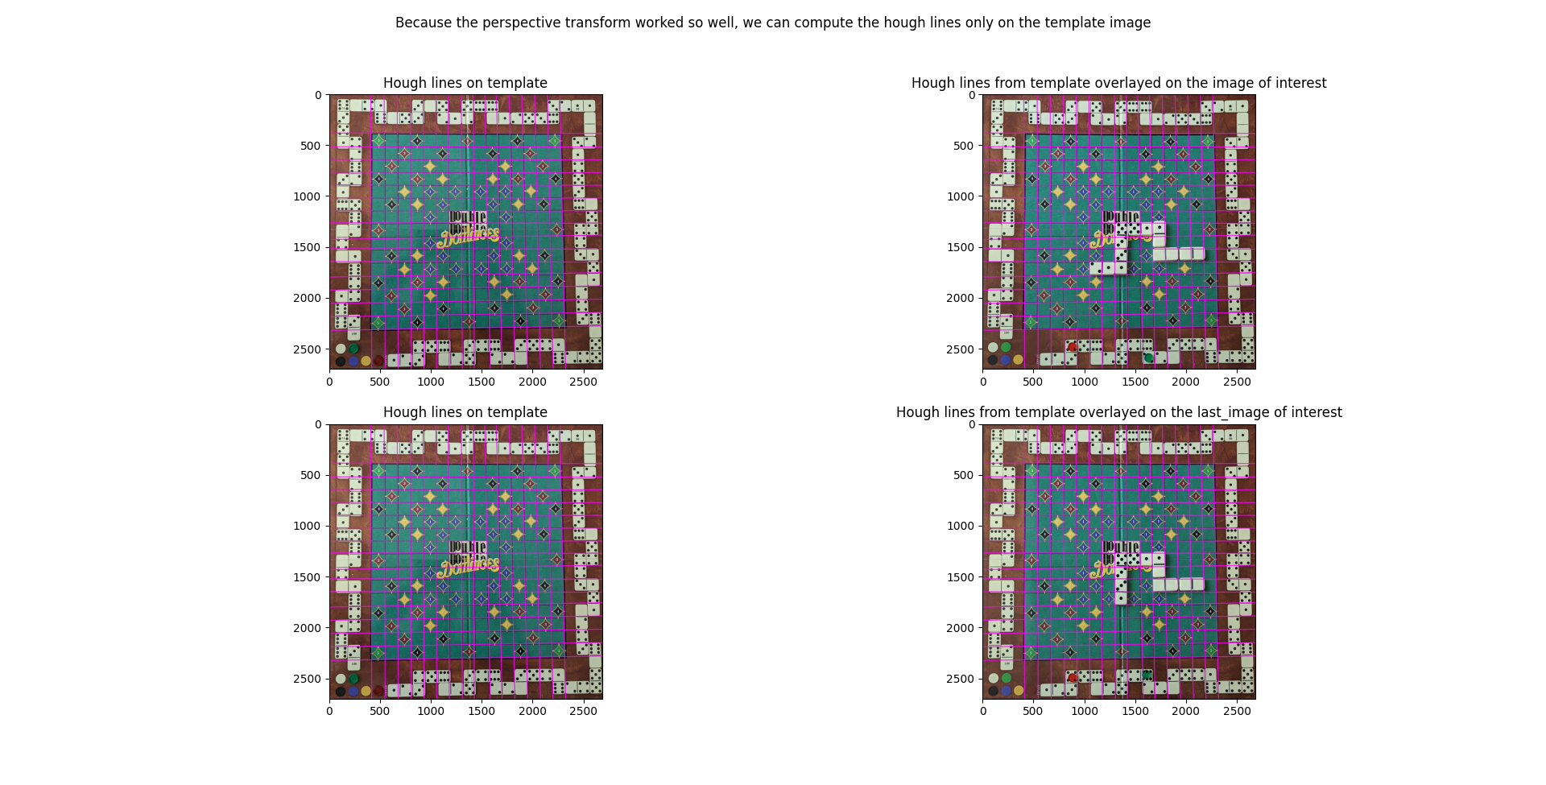

### Heat map

By subtracting the background from the image (either the previous image or the template if we are working on the first image of a game) of interest and applying a threshold, heat map can be created which can be used in locating the newly placed domino piece. By iterating step by step over the patches provided by Hough Line Transform, we can compute the mean brightness of the patch and choose the maximum out of all of them. Then we can simply compute the maximum brightness patch adjacent in a cross like pattern.

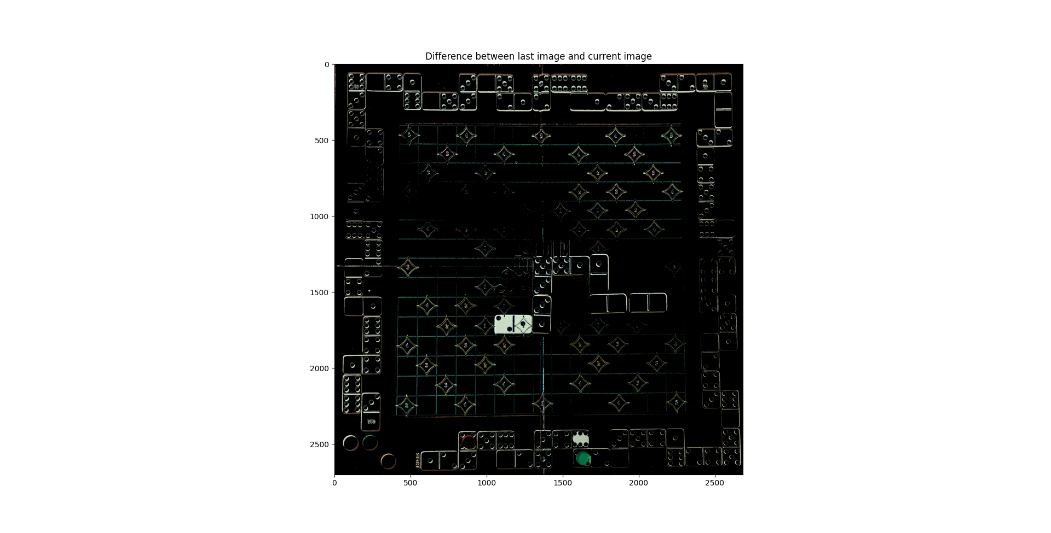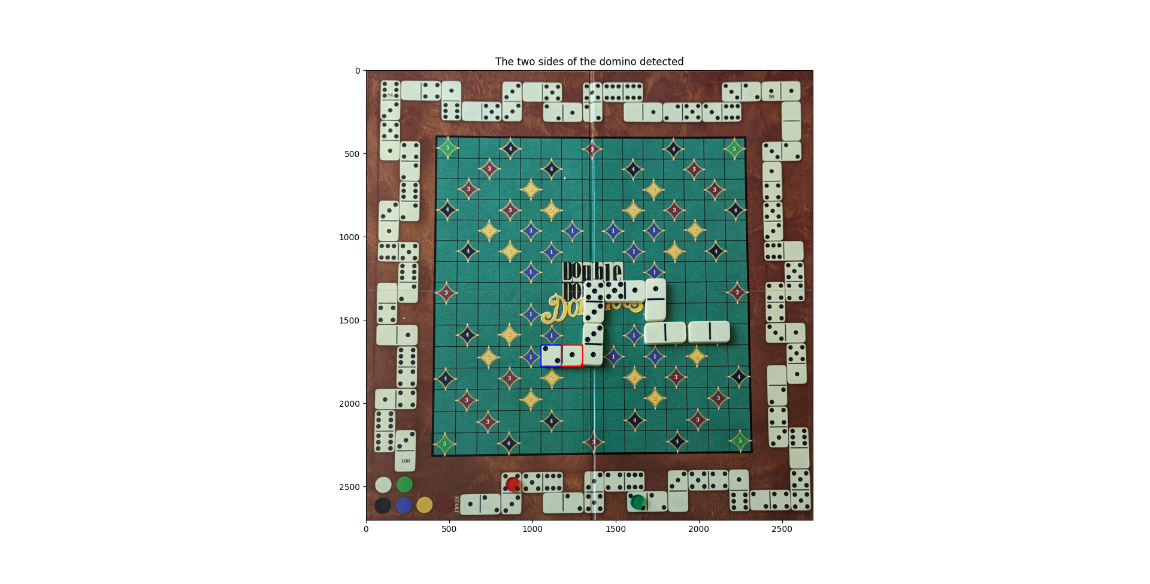

### Detecting dots using Hough Circles

This step was very easy to implement, although some errors are prone to exist due to bad alignment or improper placement of the domino in its space. If the better part of the dot is outside of the focused patch it can lead to a sub estimation. This method is also prone to supra estimation if another foreign domino enters the area under investigation.

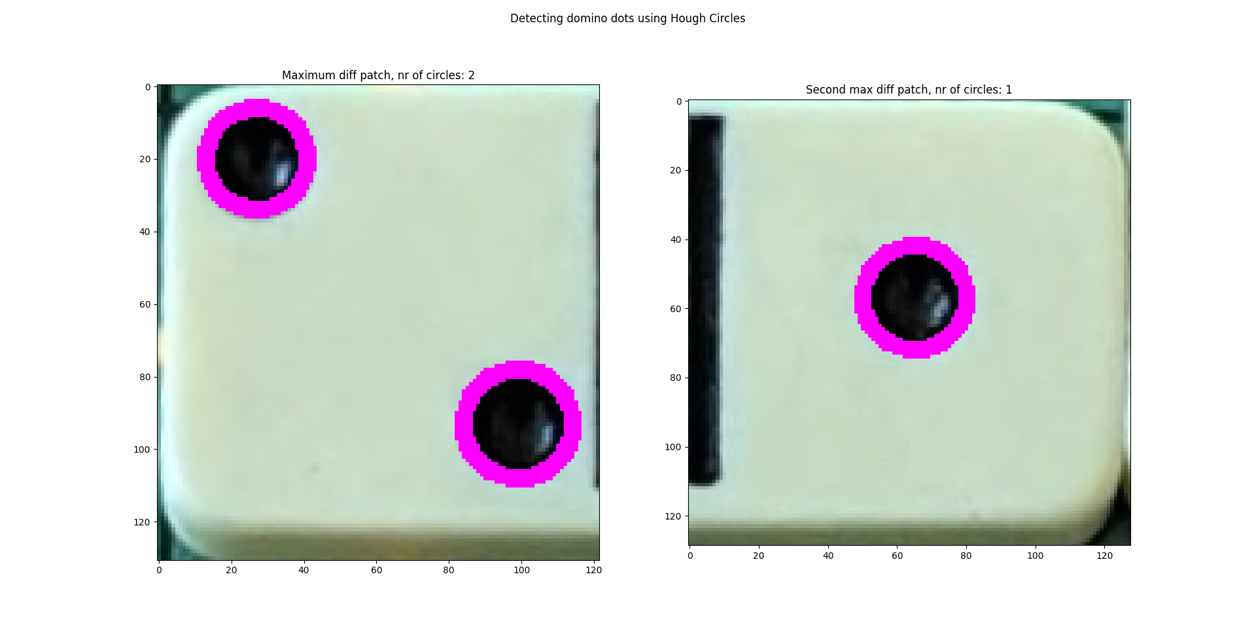

## Conclusion

In conclusion, following all the above steps, we now possess all the information needed to completing this task.

# Bonus task

The same idea presented above was used for the bonus task until the heat map step. Here it proved problematic to classify which halves belong to the same domino, so the enforcement of “• a domino doesn’t match the head or end of the domino that is attached to” was not implemented.

The other three bullets have in common the presence of a 2x2 square made of dominoes, whose existence is quite easy to deny or confirm by checking the neighbors of all the activations from the heat map and by eliminating the overlaps.